Project Performance Test

Date | 13 July 2026
Team ID | SWTID-2026-4732
Project Name | India's Agricultural Crop Production Analysis
Maximum Marks

Model Performance Testing:
Project team shall fill the following information in model performance testing template.
S.No. | Parameter | Screenshot / Values
1. | Data Rendered | 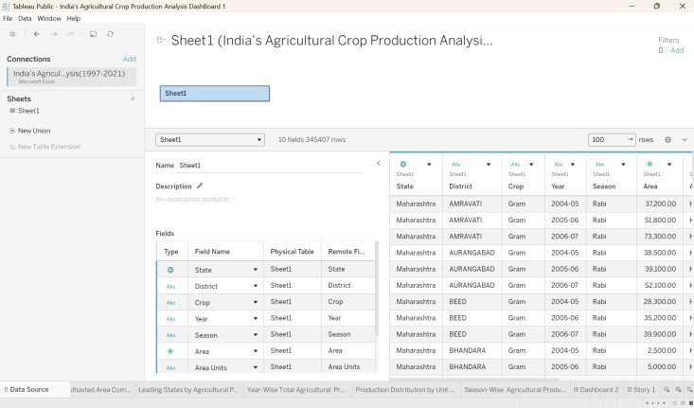  Values:  Total States: 33  Total Districts: 646  Total Crop Types: 124  Total Seasons: 6  Total Records: 345,407  Total Cultivated Area: 430 Million Hectares  Total Production: 10.8 Billion Tonnes  Average Production per Year: 432 Million Tonnes  Highest Producing State: Uttar Pradesh  Highest Produced Crop: Rice  Lowest Produced Crop: Safflower  Study Period: 1997–2021
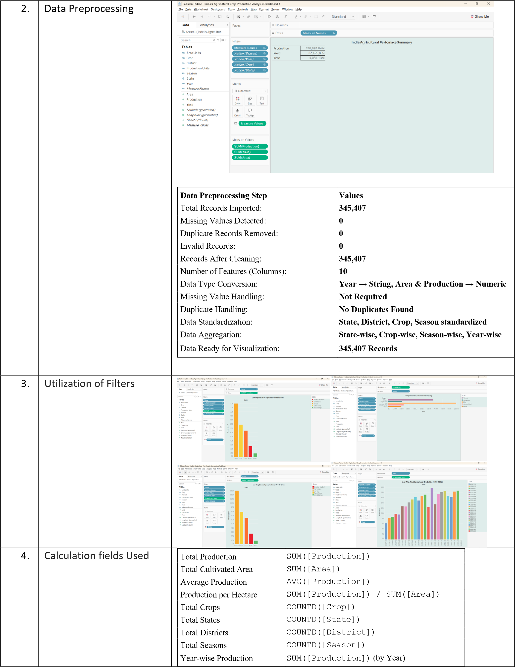
5. | Dashboard design | No of Visualizations / Graphs :  Dashboard Design:  - No. of Worksheets: 10  - No. of Dashboards: 2  - No. of Tableau Stories: 1  - No. of Visualizations / Graphs: 12  Visualizations Used:  - KPI Cards (Total Production, Total Area, Total Crops)  - Bar Chart – Crop-wise Production  - Line Chart – Year-wise Production Trend  - Filled Map – State-wise Production  - Pie Chart – Season-wise Production  - Tree Map – Crop Distribution  - Stacked Bar Chart – State vs Crop Production  - Area Chart – Production Trend  - Highlight Table – State-wise Comparison  - Packed Bubble Chart – Crop Production Analysis  - Horizontal Bar Chart – Top Producing States  - Filter Panel (State, Crop, Season, Year)
6 | Story Design | No of Visualizations / Graphs : Story Design:  - No. of Stories: 1  - No. of Story Points (Pages): 5 • No. of Visualizations / Graphs: 10  Story Flow:  - Overview of India's Agricultural Cultivation (KPI Cards)  - State-wise Crop Production Analysis (Filled Map + Bar Chart)  - Year-wise Production Trend (Line Chart + Area Chart)  - Season-wise and Crop-wise Analysis (Pie Chart + Tree Map + Stacked Bar Chart)  - Key Insights & Conclusion (Dashboard Summary + Filters + KPI Cards)

